

(4)2 - 2(4) - 8 = 0

16 - 8 - 8 = 0

0 = 0



(5)2 + a(5) + b = 0 (-2)2 + a(-2) + b = 0

25 + 5a + b = 0 4 - 2a + b = 0

b = -25 - 5a

4 - 2a + (-25 - 5a) = 0

4 - 2a - 25 - 5a = 0

-21 -7a = 0

7a = -21

a = -21/7

a = -3

b = -25 - 5(-3)

b = -25 + 15

b = -10

Check:

(5)2 - 3(5) - 10 = 0 (-2)2 - 3(-2) - 10 = 0

25 - 15 - 10 = 0 4 + 6 - 10 = 0

0 = 0 0 = 0



a = 5, b = -2, c = -9

$$x=\frac{-b±\sqrt{b^{2}-4ac}}{2a}$$

$$x=\frac{-(-2)±\sqrt{{(-2)}^{2}-4(5)(-9)}}{2(5)}$$

$$x=\frac{2±\sqrt{4+180}}{10}$$

$$x=\frac{2±\sqrt{184}}{10}$$

$$x=\frac{2±\sqrt{4}\sqrt{46}}{10}$$

$$x=\frac{2±2\sqrt{46}}{10}$$

$$x=\frac{1±\sqrt{46}}{5}$$

$$x=\frac{1±6.782}{5}$$

$$x=\frac{1+6.782}{5} x=\frac{1-6.782}{5}$$

$$x=\frac{7.782}{5} x=\frac{-5.782}{5}$$

$$x=1.556 x=-1.156$$

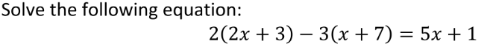

4x + 6 - 3x - 21 = 5x + 1

4x - 3x - 5x = 1 + 21 - 6

- 4x = 16

x = 16/-4

x = - 4

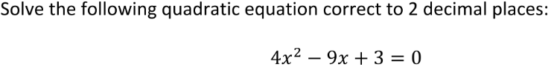

a = 4, b = -9, c = 3

$$x=\frac{-b±\sqrt{b^{2}-4ac}}{2a}$$

$$x=\frac{-(-9)±\sqrt{{(-9)}^{2}-4(4)(3)}}{2(4)}$$

$$x=\frac{9±\sqrt{81-48 }}{8}$$

$$x=\frac{9±\sqrt{33}}{8}$$

$$x=\frac{9±5.74}{8}$$

$$x=\frac{9+5.74}{8} x=\frac{9-5.74}{8}$$

$$x=1.84 x=0.41$$

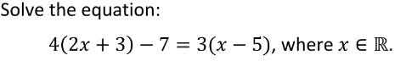

4(2x + 3) - 7 = 3(x - 5)

8x + 12 - 7 = 3x - 15

5x = -20

x = -20/5

x = -4

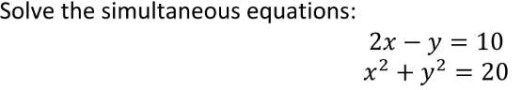

2x - y = 10 x2 + y2 = 20

y = 2x - 10 x2 + y2 = 20

x2 + (2x - 10)2 = 20

x2 + (2x - 10)(2x - 10) = 20

x2 + 4x2 - 20x - 20x + 100 = 20

5x2 - 40x + 100 = 20

x2 - 8x + 20 = 4

x2 - 8x + 16 = 0

x = 4

y = 2(4) - 10

y = 8 - 10

y = -2

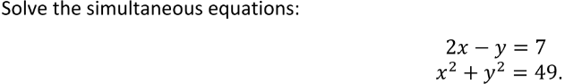

2x - y = 7 x2 + y2 = 49

y = 2x - 7 x2 + (2x - 7)2 = 49

x2 + (2x - 7)(2x - 7) = 49

x2 + 4x2 - 14x - 14x + 49 = 49

5x2 - 28x = 0

y = 2(0) - 7

y = 0 - 7

y = - 7

y = 2(28) - 7

y = 56 - 7

y = 49

x = 0 & y = -7

x = 28 & y = 49